1. <http://1indus.com/admin/Admin_UploadDocs.aspx> :Documents

without selecting folder present in resume if we directly upload file then we are getting error.

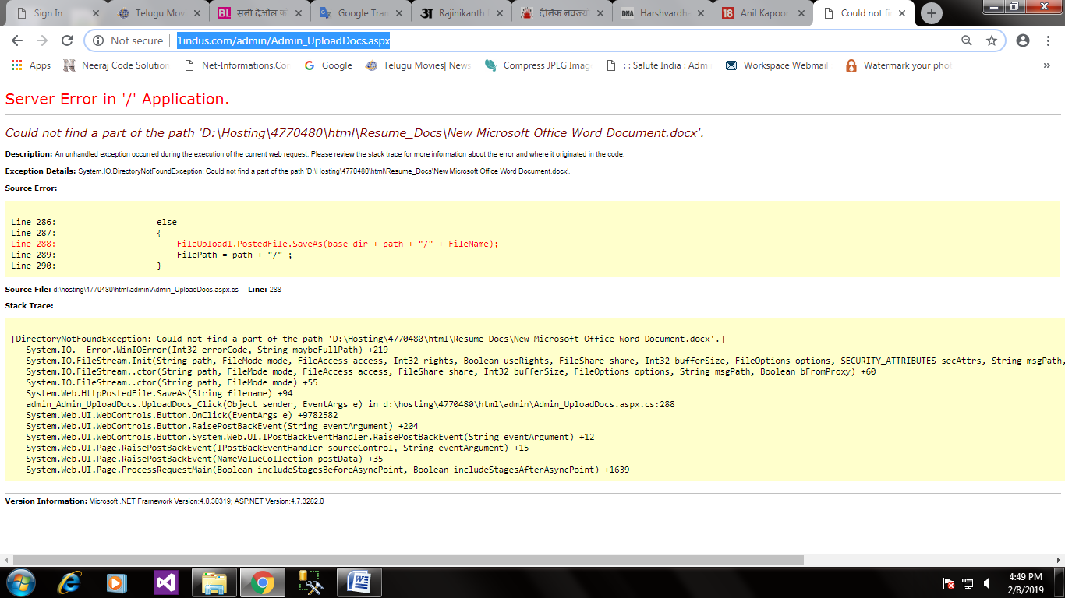

1. <http://1indus.com/admin/Admin-Principles.aspx>

after selecting options of text box

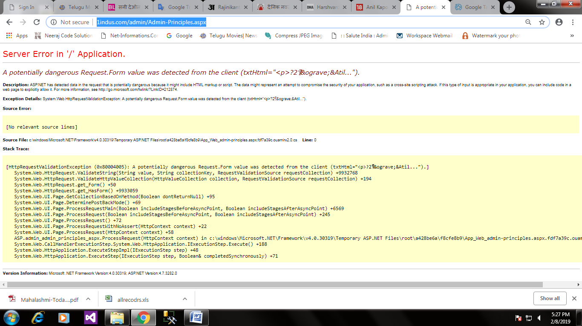

1. <http://1indus.com/admin/Admin-Salary-Statement.aspx>

salary display display particular month or all at time.

